   |  | DEANSHIP FOR RESEARCH  MONTHLY DRAWDOWNS FUNDS PROCEDURE
PROCESS: Post- Award Division Standard Procedures
POLICY REFERENCE: SIA Prod (ORACLE) Manual

PURPOSE: Utilize the SIA Prod (ORACLE) platform to create expenses reports.

ISSUE DATE:  March 2019 | LAST AMENDED DATE: |  | EFFECTIVE DATE:  3/21/19
RELATED FORMS:
N/A

DIRECTOR APPROVAL: |  |  |  | APPROVAL DATE:

INTRODUCTION:
Since September 2016, the Center for Research Compliance and Development (CRECED) is in charge of all the research. The Deanship for Research has the commitment to enforce the regulations established by the University of Puerto Rico and in the same way continue to promote research in our institution. Also, the center will continue to promote a research culture by partnering with other programs/units to enhance research education across all MSC schools and aligning efforts to promote research.
PURPOSE:
- Establish the procedure to retrieve a monthly report of drawdowns funds, using the SIA prod (ORACLE) platform.

PROCEDURE:
- ORACLE Procedure
- Verify the final day of the last drawdown to avoid duplication of expenses in the petition.
- After the confirmation of the last day of expenses requested in the past drawn down, access in Oracle accounting system, and select Discoverer View.
- Select the report Grant Cash Draw Request- RCM and the option Account by Project and Funds, this report provides the net of debits and credits sorted by Project, agency, expense code and type of transaction.
- Once we select the report we enter the values for Fund, Project and the start and end dates from which we are going to make the funds request.
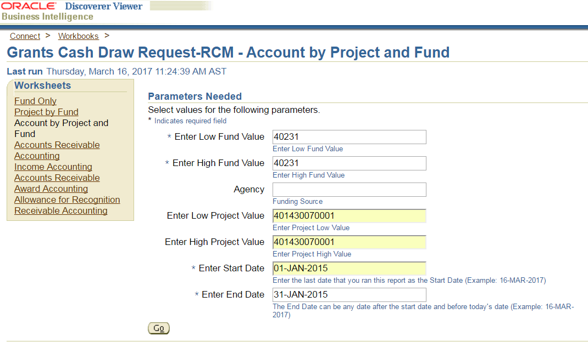

- After we have the Grants Cash Draw Request report we select the UPR Available Funds- RCM report. This report is necessary to corroborate that the previous cumulative cash disbursements and the amount in the Cash Draw Request match the total project expenses at that date.
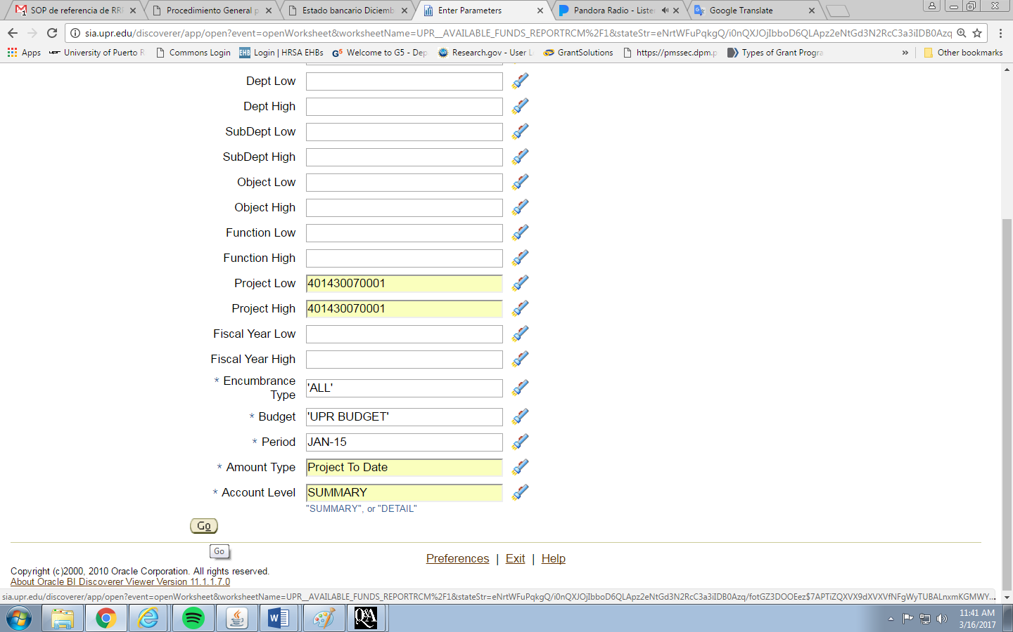
- Next step is to include the new expenses in the “working paper” by adding a new column and detailing the expenses in every category. After that, we calculate the indirect cost portion base on the allowable direct costs.
- In the Inquiry Funds section on the Accounting system we must verify if the last (and every) drawdown it’s in the account properly posted.
- We repeat these processes with every NSF account.

SYSTEM PROCEDURE
  - National Science Foundation - ACM$ Procedure
- You must log in to Research.gov and select Award Cash Management Service. Then click “continue” in the Submit New Transaction section.
- The system will take you to a window which has all the active Grant of our institution. You must verify that the Previous Cumulative Cash Disbursement match to your records. In the Payment Amount Request Section enter the new request for every account separately and click save.
- If there is no adjustment continue to Step 3 to review your request and forward for certification.
- The supervisor must approve the request for this to be valid.

- Department of Education – G5 Payment Request
- You must log in to www.g5.gov .
- Select Payment on the menu bar then click on Create Payments under Payment Request section.
- Look up for the Grant to draw down. You must verify that the Available Balance in system match our records.
- Enter the request amount under Payment Amount and select a Deposit Date. Click Continue at the end of the page.
- Confirm that the information is correct and Certify/Summit the request.
- Save the confirmation draw down evidence for our records.

- Environmental Protection Agency - ASAP Payment Request
- You must log to: www.asap.gov
- Accept terms and conditions of ASAP.gov
- Select Payment Request on the menu bar then click on Initiate Payment Request (PR).
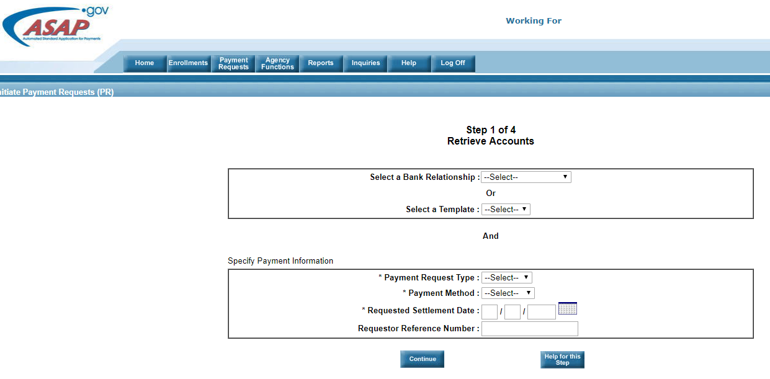

- Select the bank Account on the drop down menu of Select a Bank Relationship
- Select Individual on the drop down menu of *Payment Request Type
- Select ACH on the drop down menu of *Payment Method
- Select a date on *Requested Settlement Date to receive the draw down, it must be a labor day
- Write an unique reference number to identify this petition on Requestor Reference Number and press Continue
- Write the Grant Number on Account ID (or partial) and press continue
- Verify that the Available Balance in system match our records.
- Enter the request amount under Amount Requested and press continue.
- Confirm that the information is correct and Summit the request
- Save the confirmation draw down evidence for our records

INCOME ADJUSTMENT
- In the upcoming days after the drawn down request the institution will receive the deposit.
- Identify and reconcile the deposit with the institution bank account by preparing the adjustment to recognize the income in the pertinent project account.

